**Islamic University of Technology**

**CSE 4508**

**Lab Report 3**

**Name** : Amina

**Student ID** : 200041155

**Section** : 1

**Lab Group** : 1B (shifted from 1A)

**Date of Performance** : 30/08/23

**Date of Submission** : 31/08/23

Task A

At first we will create 3 tables in our database and insert some data within the tables.

create table Products(

    product_id int primary key,

    name varchar2(40),

    unit_price int

);

create table Orders(

    order_id int primary key,

    customer_id int,

    order_date varchar2(22)

);

create table Order_items(

    order_id int,

    product_id int,

    quantity int,

    CONSTRAINT fk_order_items_order_id FOREIGN KEY (order_id) REFERENCES Orders(order_id),

    CONSTRAINT fk_order_items_product_id FOREIGN KEY (product_id) REFERENCES Products(product_id)

);

insert into Products values(20 , 'Doll', 20);

insert into Products values(21 , 'Socks', 30);

insert into Products values(22 , '4- dimensional pocket', 3000);

insert into Products values(23 , 'Anywhere door', 2000);

insert into Products values(24 , 'Small light', 200);

insert into Products values(25 , 'Big light', 300);

insert into Products values(26 , 'Bamboo copter', 50);

insert into Products values(27 , 'Time machine', 5000);

insert into Products values(28 , 'Air canon', 200);

insert into Products values(29 , 'Animal beam', 220);

insert into Orders values(500 , 1000, 'July 20, 2023');

insert into Orders values(501 , 1001, 'June 13, 2023');

insert into Orders values(502 , 1002, 'June 24, 2023');

insert into Orders values(503 , 1003, 'July 26, 2023');

insert into Orders values(504 , 1004, 'June 17, 2023');

insert into Orders values(505 , 1005, 'July 19, 2023');

insert into Orders values(506 , 1006, 'June 20, 2023');

insert into Orders values(507 , 1007, 'July 30, 2023');

insert into Orders values(508 , 1008, 'July 23, 2023');

insert into Orders values(509 , 1009, 'June 12, 2023');

insert into Order_items values(509 , 23, 23);

insert into Order_items values(508 , 23, 2);

insert into Order_items values(507 , 24, 4);

insert into Order_items values(505 , 22, 5);

insert into Order_items values(501 , 22, 6);

insert into Order_items values(500 , 26, 7);

insert into Order_items values(508 , 26, 2);

insert into Order_items values(507 , 27, 3);

insert into Order_items values(507 , 28, 5);

insert into Order_items values(503 , 21, 6);

insert into Order_items values(502 , 20, 3);

Query for A1 :

select subtable.pid, sum(nvl(subtable.np, 0)) as total_revenue

from (select Products.product_id as pid, Order_items.order_id as oid, (nvl(Products.unit_price, 0) * nvl(Order_items.quantity, 0)) as np

      from Products, Order_items

      where Products.product_id = Order_items.product_id) subtable, Orders

where Orders.order_id = subtable.oid AND

      Orders.order_date like '%June%'

group by subtable.pid;

Result :

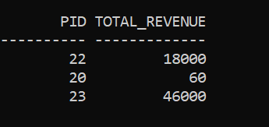

Query for A2 :

select *

from(select rownum as serial, totals.product_id as product_id, totals.total_quantity as total_quantity

    from(select oi.product_id as product_id, sum(nvl(oi.quantity, 0)) as total_quantity

         from order_items oi,(select *

                             from orders o

                             where o.order_date like '%July%') fromJuly

        where oi.order_id = fromJuly.order_id

        group by oi.product_id

        order by total_quantity desc) totals) finally

where finally.serial <=5;

Result :

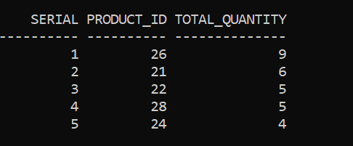

Query for A3 :

--A3

select customer_id from(

    select customer_id, sum(quantity * unit_price) as total_money

    from Products, Orders, Order_items

    where Products.product_id = Order_items.product_id and

        Orders.order_id = Order_items.order_id and

        order_date like '%July%'

    group by Orders.customer_id

)

where total_money >= 1000;

Result :

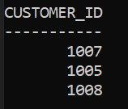

Query for A4 :

--A4

update Products set unit_price = 1.5 * unit_price

where product_id in

(

    select Products.product_id

    from Products, Orders, Order_items

    where Products.product_id = Order_items.product_id and

        Orders.order_id = Order_items.order_id and

        order_date like '%July%'

    group by Products.product_id

    having sum(quantity) >= 5

);

Result : 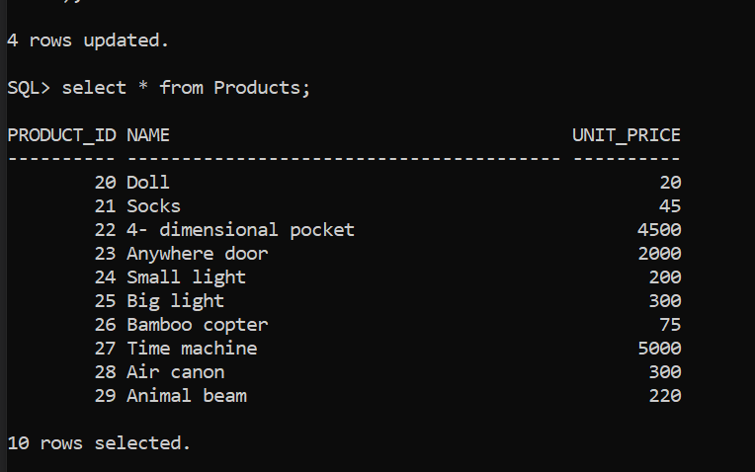

Previous Table :

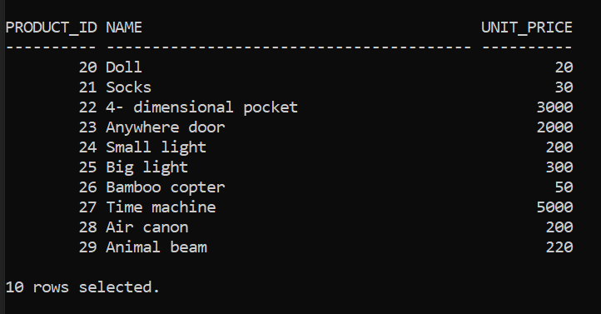

Task B

In Task B, we were asked to demonstrate the use of some built-in functions. The examples are given below.

**CONCAT**:

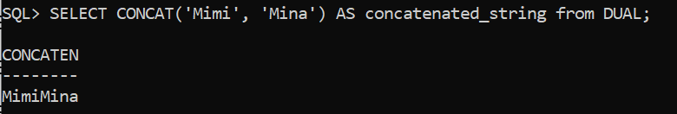

**INSTR**:

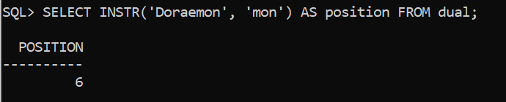

**LOWER**:

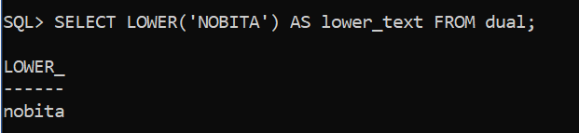

**UPPER**:

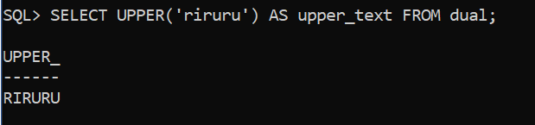

**LENGTH**:

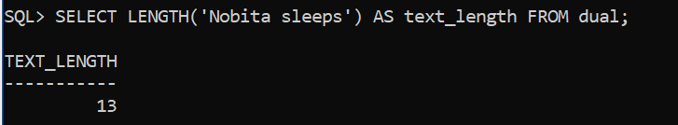

**L/R PAD:**

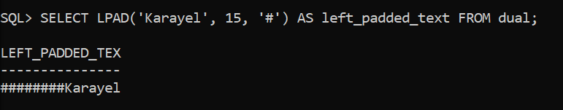

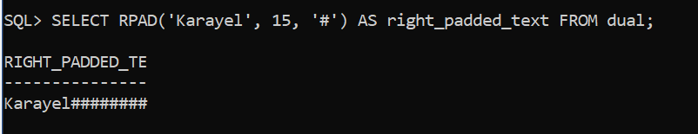

**L/R TRIM:**

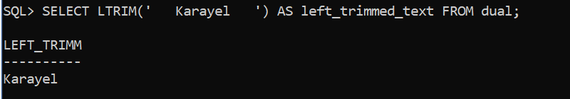

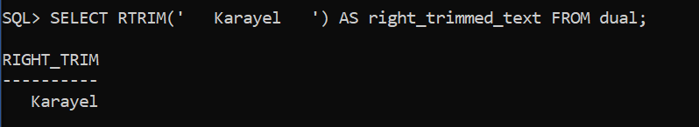

**SUBSTR**:

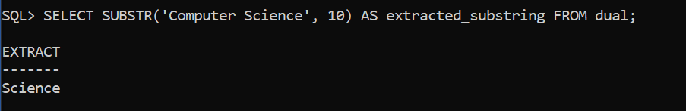

**COUNT**:

